Java8 Assignment

//Ques1 : Write the following a functional interface and implement it using lambda:
//
// (1) First number is greater than second number or not Parameter (int ,int ) Return boolean
// (2) Increment the number by 1 and return incremented value Parameter (int) Return int
// (3) Concatination of 2 string Parameter (String , String ) Return (String)
// (4) Convert a string to uppercase and return . Parameter (String) Return (String)

@FunctionalInterface
interface myinterface{
boolean comparison(int n1,int n2);
}
@FunctionalInterface
interface modify{
int modify(int n1);
}
@FunctionalInterface
interface concat{
String concatenation(String str1,String str2);
}
@FunctionalInterface
interface upper{
String convertupper(String str);
}
public class Ques1 {
public static void main(String[] args) {
myinterface m1 = (int n1, int n2) -> {
if (n1 > n2)
return true;
else
return false;
};
System.out.println("Is first number greater than second number: "+m1.comparison(2, 3));
modify m2 = (int n1) -> {
n1 = n1 + 1;
return n1;
};
System.out.println("After increment by 1, the number is: "+m2.modify(4));
concat c1 = (String str1, String str2) -> {
String strconcat = str1 + str2;
return strconcat;
};
System.out.println("Concatenation of two string is : "+c1.concatenation("gunjan ", "dawar"));
upper u1 = (String str) -> {
str = str.toUpperCase();
return str;
};
System.out.println("Converting string to upper case : "+u1.convertupper("gunjan"));
}
}

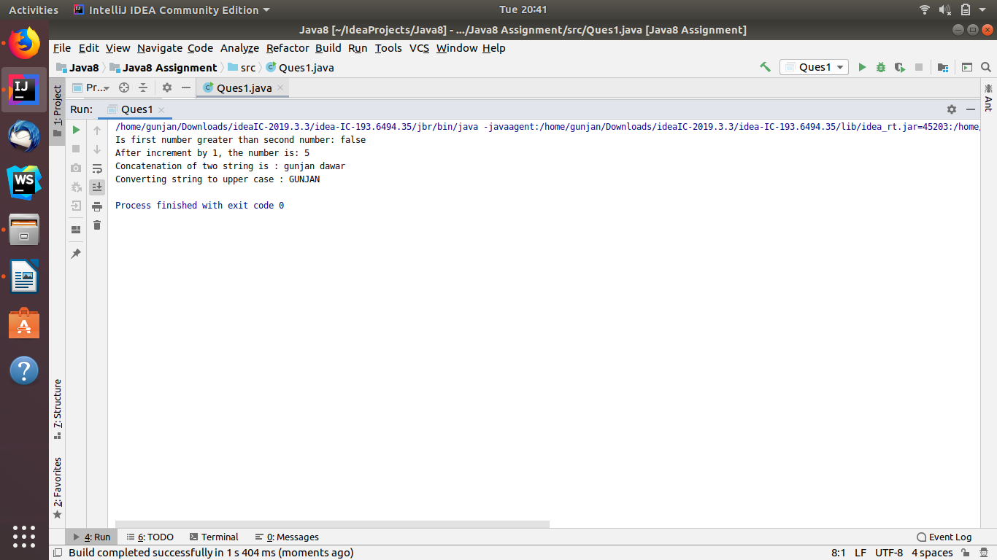

//Q2 Create a functional interface whose method takes 2 integers and return one integer.
@FunctionalInterface
interface secondinterface{
int display(int n1,int n2);
}
public class Ques2 {
public static void main(String[] args) {
secondinterface m1=(int n1, int n2)-> {
n1=n1+n2;
return n1;
};
System.out.println("Addidtion of two integers is : "+m1.display(4,5));
}
}
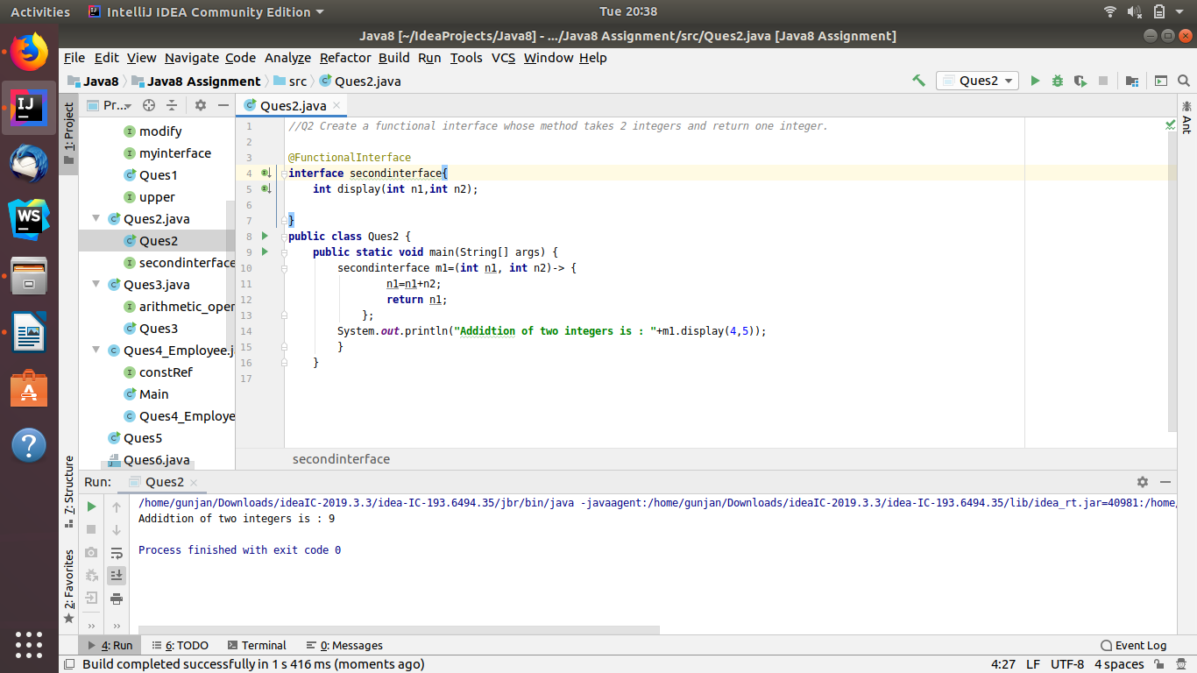

//Q3 Using (instance) Method reference create and apply add and subtract method and
// using (Static) Method reference create and apply multiplication method for the functional interface created.
interface arithmetic_operation{
int operation(int n1,int n2);
}
public class Ques3 {
int add(int n1,int n2)
{
int sum=n1+n2;
return sum;
}
int subtract(int n1,int n2){
int diff=n1-n2;
return diff;
}
static int multiplication(int n1,int n2){
int mul=n1*n2;
return mul;
}
public static void main(String[] args) {
arithmetic_operation a1=new Ques3()::add;
System.out.println(("Addition of two numbers is : "+a1.operation(1,2)));
arithmetic_operation s1=new Ques3()::subtract;
System.out.println(("Subtraction of two numbers is : "+s1.operation(3,2)));
arithmetic_operation a3=Ques3::multiplication;
System.out.println("Multiplication of two numbers is : "+a3.operation(3,3));
}
}
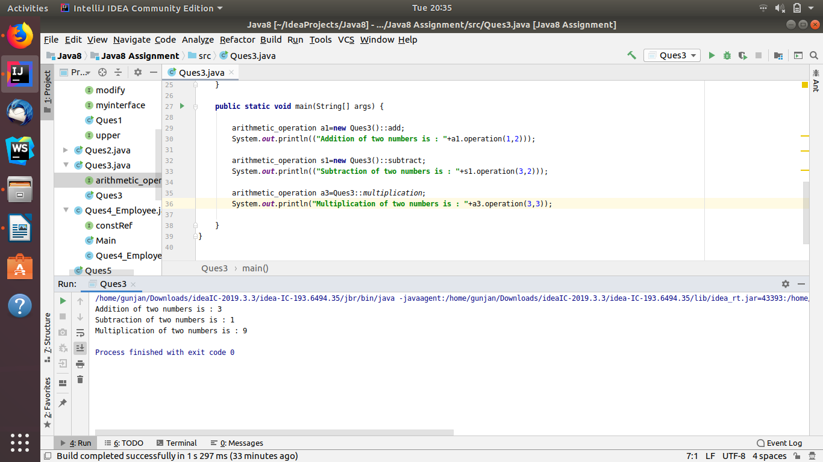

//Ques4 Create an Employee Class with instance variables (String) name, (Integer)age, (String)city
// and get the instance of the Class using constructor reference
interface constRef{
Ques4_Employee details(String name,int age,String city);
}
public class Ques4_Employee {
String name;
int age;
String city;
Ques4_Employee(String name, int age, String city) {
this.name = name;
this.age = age;
this.city = city;
}
void printdetails() {
System.out.println("NAME: "+name + " AGE: " + age + " CITY: " + city + " ");
}
}
class Main{
public static void main(String[] args) {
constRef c1=Ques4_Employee::new;
Ques4_Employee employee1 = c1.details("gunjan",12,"delhi");
employee1.printdetails();
}
}
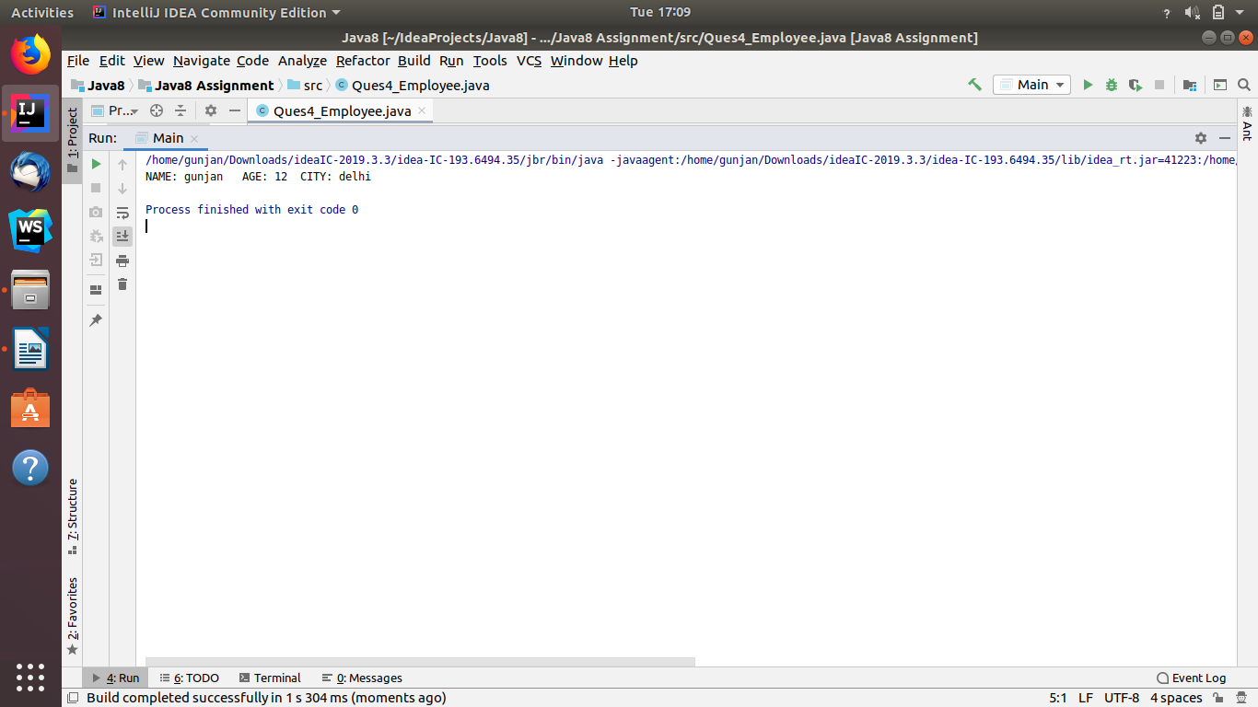

//Q5 Implement following functional interfaces from java.util.function using lambdas:
//
// (1) Consumer
//
// (2) Supplier
//
// (3) Predicate
//
// (4) Function
import java.util.function.Consumer;
import java.util.function.Function;
import java.util.function.Predicate;
import java.util.function.Supplier;
public class Ques5 {
static void print(String name){
System.out.println("Hello "+name);
}
public static void main(String[] args) {
//Consumer Functional Interaface:
Consumer<String> consumer1 = (String s)-> { System.out.println("Implementing Consumer Functional Interface: "+s); };
consumer1.accept("John");
//Supplier Functional Interface"
Supplier<Double> randomValue = () -> Math.random();
System.out.println("Implementing Supplier Functional Interface: "+randomValue.get());
//Predicate Functional Interface
Predicate<Integer> lesserthan = i -> (i < 18);
System.out.println("Implementing Pedicate Functional Interface: "+lesserthan.test(10));
//Function Functional Interafce:
Function<Integer, Double> half = a -> a / 2.0;
System.out.println("Implementing Function Functional Interface : "+half.apply(10));
}
}
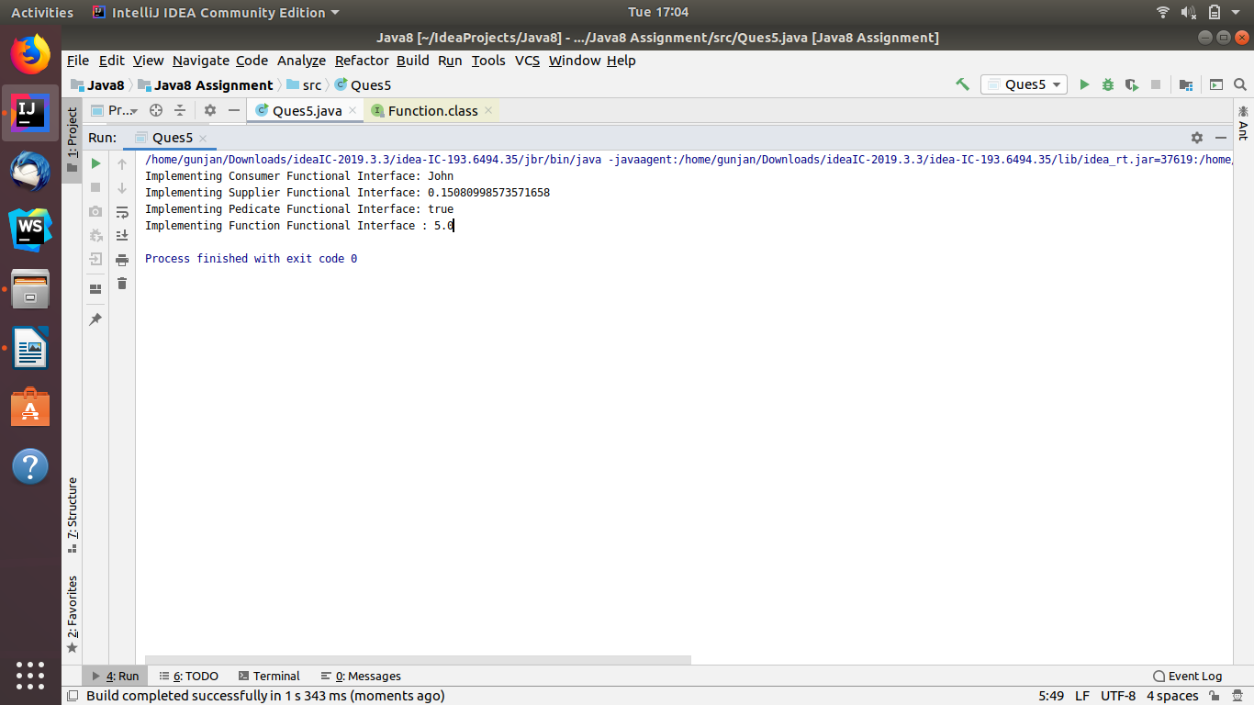

//Q6 Create and access default and static method of an interface.
package Ques6;
interface inter1{
default void display(){
System.out.println("Inside default method..");
}
}
public class Ques6_default implements inter1 {
public static void main(String[] args) {
Ques6_default a1=new Ques6_default();
a1.display();
}
}
------------------------------------------------

package Ques6;
interface inter2{
static void display1(){
System.out.println("Inside Static Method.... ");
}
}
class Ques6_static implements inter1 {
public static void main(String[] args) {
inter2.display1();
}
}
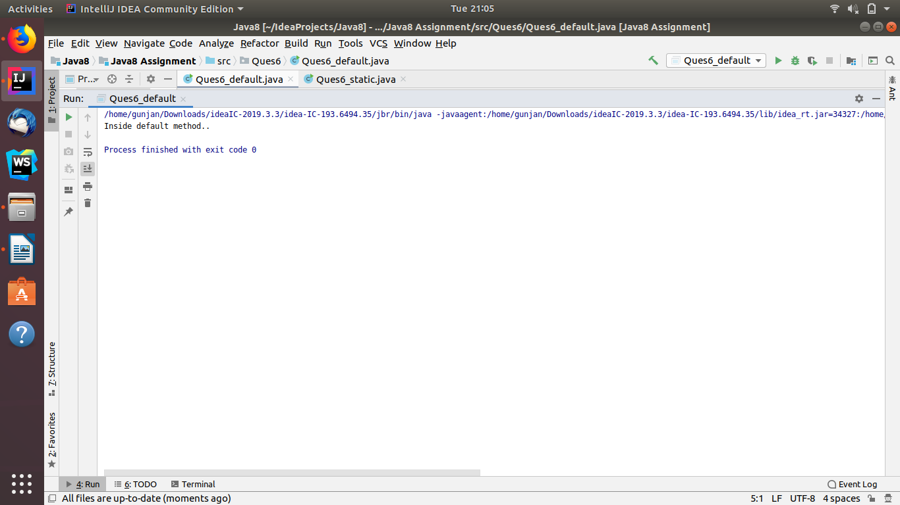

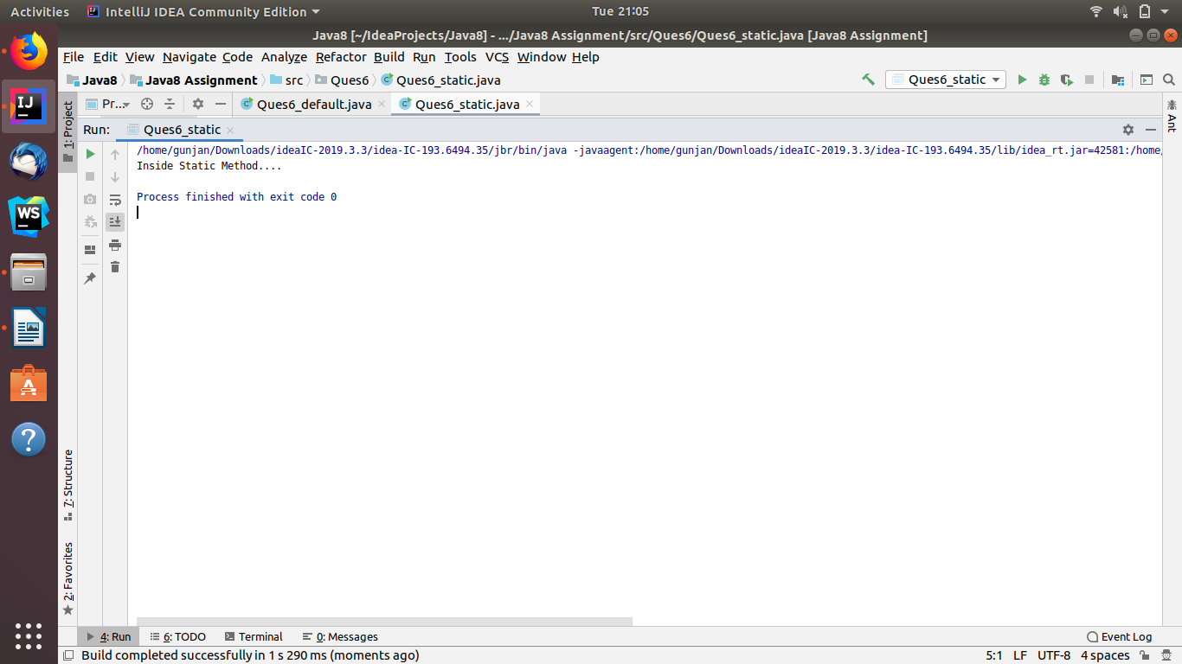

//Ques7 Override the default method of the interface
interface default_inter{
default void display(){
System.out.println("Inside default method");
}
}
public class Ques7 implements default_inter{
@Override
public void display() {
System.out.println("Overriding interface default method");
}
}
class Main1{
public static void main(String[] args) {
Ques7 q7=new Ques7();
q7.display();
}
}
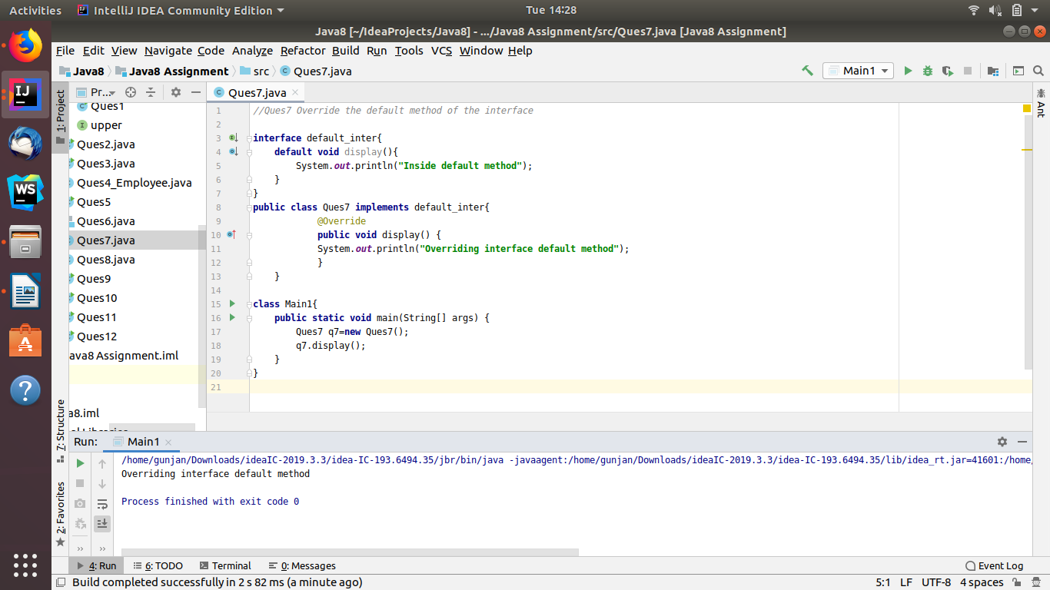

//Q8 Implement multiple inheritance with default method inside interface.
interface TestInterface1{
default void show() {
System.out.println("Default TestInterface1");
}
}
interface TestInterface2 {
default void show() {
System.out.println("Default TestInterface2");
}
}
class Ques8 implements TestInterface1, TestInterface2 {
// Overriding default show method
public void show() {
System.out.println("Hello from overridden method");
TestInterface1.super.show();
TestInterface2.super.show();
}
}
class Main_8{
public static void main(String args[])
{
Ques8 d = new Ques8();
d.show();
}
}
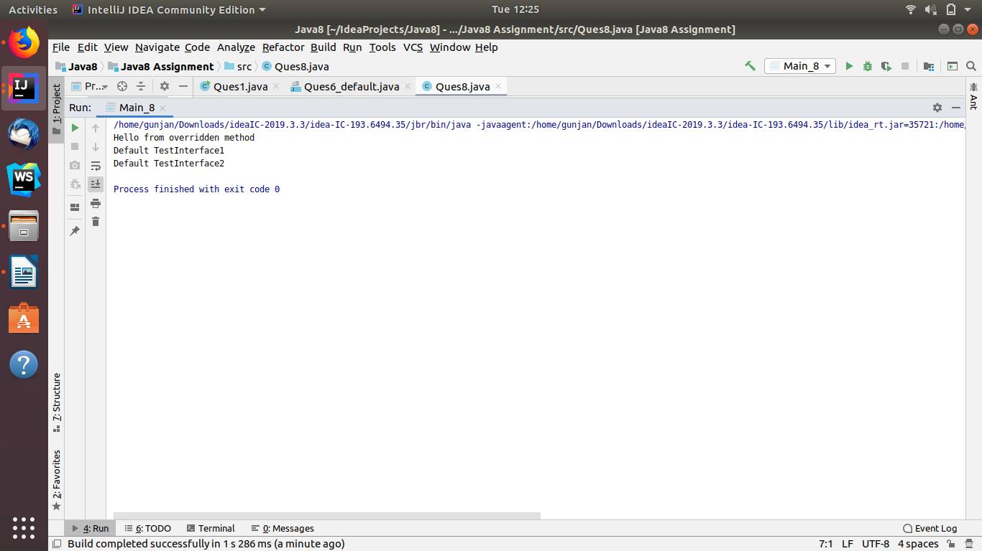

//Q9 Collect all the even numbers from an integer list.
import java.util.Arrays;
import java.util.List;
import java.util.stream.Collectors;
public class Ques9 {
public static void main(String[] args) {
List<Integer> list= Arrays.asList(1,2,3,4,5,6);
System.out.println("All the even numbers from an integer list- "+list+" are : "+
list.stream()
.filter(e->(e%2==0))
.collect(Collectors.toList())
);
}
}
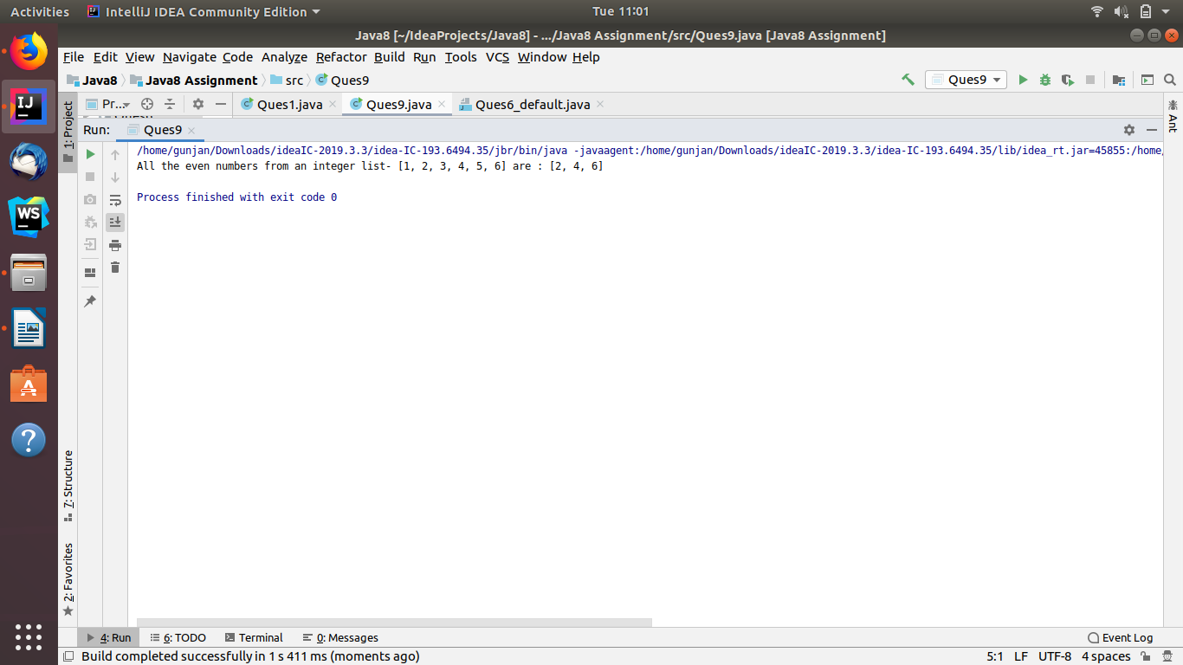

//Q10 Sum all the numbers greater than 5 in the integer list.
import java.util.Arrays;
import java.util.List;
public class Ques10 {
public static void main(String[] args) {
List<Integer> l1= Arrays.asList(1,2,3,4,5,6,7,8,9,10);
System.out.println("Sum all the numbers greater than 5 in the integer list -"+l1+" is : "+
l1
.stream()
.filter(e->e>5)
.mapToInt(e->e)
.sum()
);
}
}
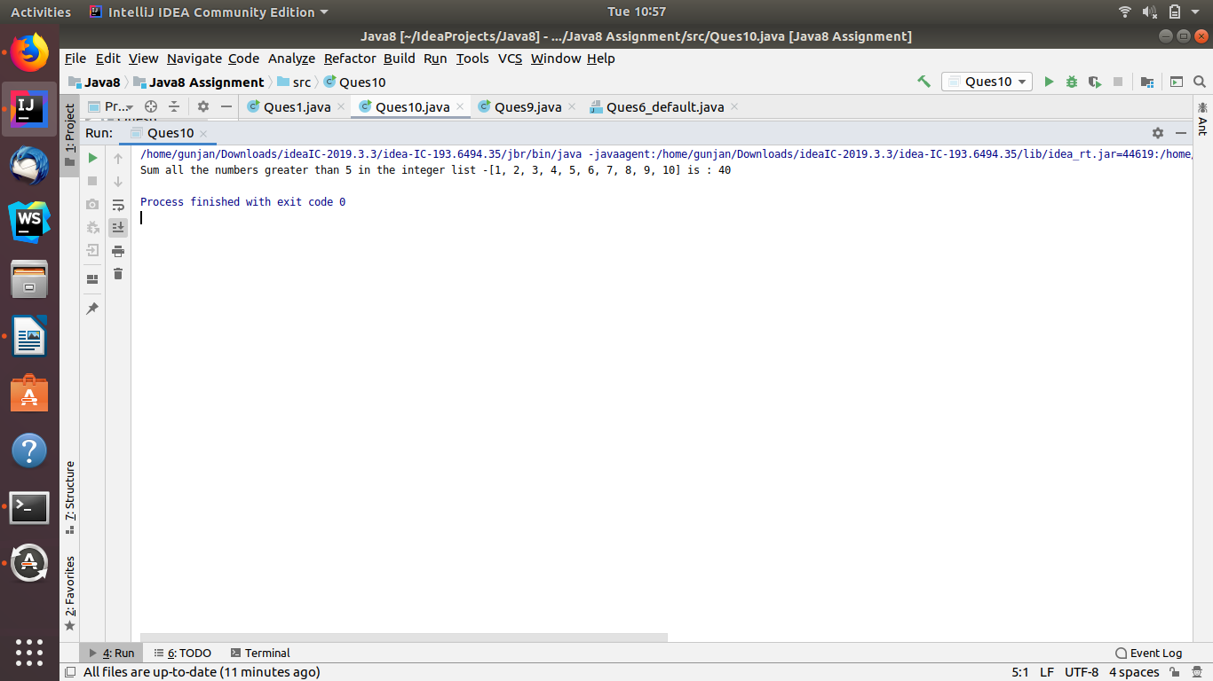

//Q11 Find average of the number inside integer list after doubling it.
import java.util.Arrays;
import java.util.List;
import java.util.stream.Collectors;
public class Ques11 {
public static void main(String[] args) {
List<Integer> l1= Arrays.asList(1,2,3,4,5,6,7,8,9,10);
System.out.println("Average of the number inside integer list -"+l1+" after doubling it is : "+
l1
.stream()
.collect(Collectors.averagingDouble(e->e*2))
);
}
}
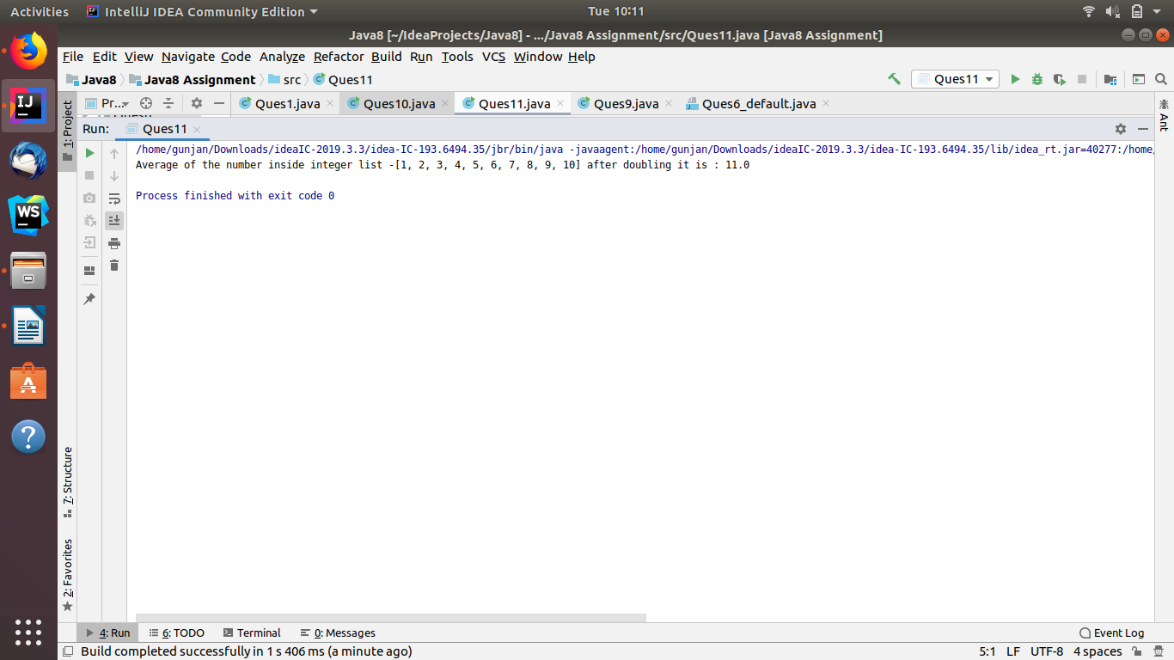

//Q12 Find the first even number in the integer list which is greater than 3.
import java.util.Arrays;
import java.util.List;
public class Ques12 {
public static void main(String[] args) {
List<Integer> l1 = Arrays.asList(1, 2, 3, 4, 5, 6, 7, 8, 9, 10);
System.out.println("First even number in the integer list 0 "+l1+" which is greater than 3 is : "+
l1
.stream()
.filter(e -> e > 3)
.filter(e->e%2==0)
.findFirst()
.get()
);
}
}
